# Ordering of spare parts

Regarding all spare parts orders to Kosan Crisplant, we kindly ask you to state the following on your order form:

1. 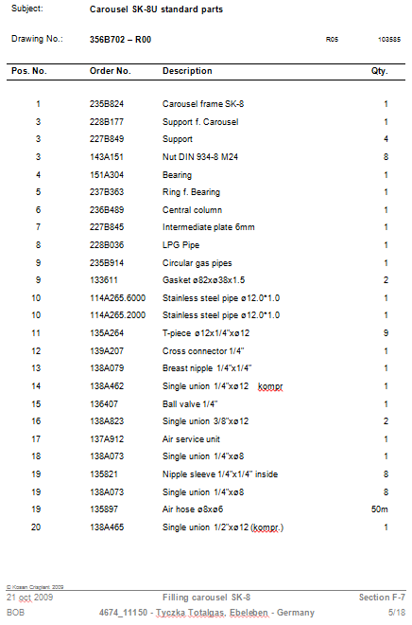 Drawing No.
2. Position No.
3. Order No.
4. Description
5. Quantity wanted
6. Section in the manual

7. Project id number

|  |  |
| --- | --- |
|  | The order form on last page can be used. |

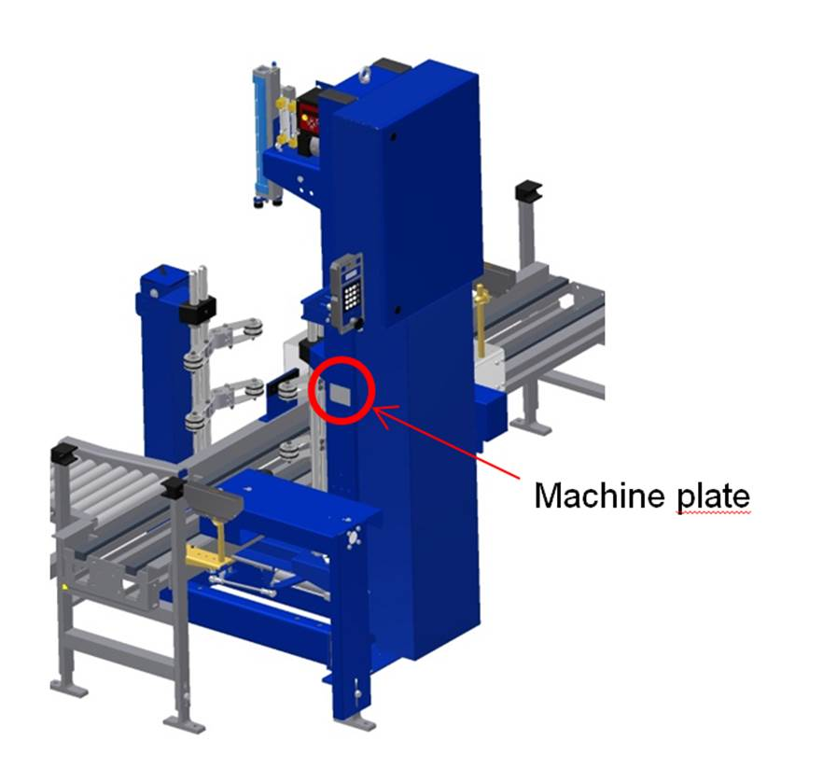Example:

1. Identify the actual part needed on the drawing in the spare parts section
2. Turn to the corresponding parts list
3. In the parts list you will find all the necessary information for making your order
4. If above mentioned is not possible, then alternatively take a picture of the machine plate, the part and its position

**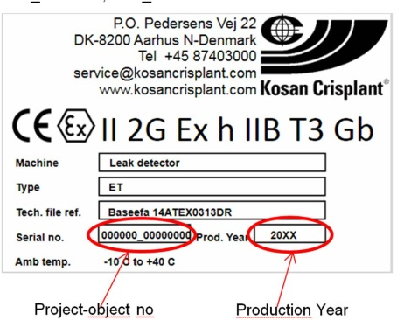*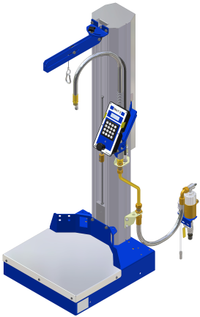Machine plate is often located as the pictures show****.*

**Production Year**

**Project-object no.**

**Machine plate**

|  |  |  |
| --- | --- | --- |
| **Kosan Crisplant a/s**  P.O. Pedersens Vej 22  8200 Aarhus N  DENMARK  Phone +45 87 40 30 00  Fax +45 87 40 30 10 | **SPARE PARTS** | |
|  | Customer | Filling plant |
|  | Date | Customer order No. |

|  |  |  |  |  |  |
| --- | --- | --- | --- | --- | --- |
| **Section** | **Drawing No./Order No.** | **Pos.** | **Qty.** | **Description** | **Stock No.** |
|  |  |  |  |  |  |
|  |  |  |  |  |  |
|  |  |  |  |  |  |
|  |  |  |  |  |  |
|  |  |  |  |  |  |
|  |  |  |  |  |  |
|  |  |  |  |  |  |
|  |  |  |  |  |  |
|  |  |  |  |  |  |
|  |  |  |  |  |  |
|  |  |  |  |  |  |
|  |  |  |  |  |  |
|  |  |  |  |  |  |
|  |  |  |  |  |  |
|  |  |  |  |  |  |
|  |  |  |  |  |  |
|  |  |  |  |  |  |
|  |  |  |  |  |  |
|  |  |  |  |  |  |
|  |  |  |  |  |  |
|  |  |  |  |  |  |